USER MANUAL

INTRODUCTION

**Problem Statement:**

Now a days there is major importance given for recycling materials as wasting materials leads to hazardous effects for environment. User faces trouble because if they want know about recycling points near to them and also end user face trouble if he is busy and has no time to come to recycling point. End user may also want to donate stuff.

**Goal:**

To provide an application for the android users to make recycling management easier in Kansas city and application must be effective to users.

**Motivation:**

To develop application which is more user friendly for product purchase and also for finding the nearest recycling point in Kansas city and also give service provider option to pick up the recycling material from user if he is not available. We also want to provide other feature for user to donate the stuff or to sell his used items. This is more helpful to the user is who is not that aware of the every nook and corner of the place.

**System Requirements:**

Operating System: Android

Android Version Support: Kitkat to Lollipop

Memory required: 256MB

Internet Connection: Yes

**Devices: Android devices**

* Bluetooth 4.0 compatible android device
* Android 4.4 or above OS

**Guidelines to use the application:**

1. Please download the R3.apk file and install it onto your mobile device.
2. Once you have installed the application, Launch the application by clicking or tapping R3 icon which will be displayed on your screen.
3. Now you can see a welcome screen with R3 logo and a welcome button.
4. Click on the welcome button to enter into the application.
5. You notice four buttons. They are Reduce, Recycle, Reuse, Sorting Guide
6. When we click on first button Recycle we will find 2 buttons. They are maps, pick up.
7. When we click on Maps we will be asked to enter our zip code. When we do it and click on button we will get list of recycling points near us. When we click on desired application we will get map of that location. On clicking second button pick up we will find two buttons in a page one is schedule pickup other is service provider.
8. When we will click on schedule pick up it will ask the user regarding the details and place and date on which we must pick up and pick up will be scheduled. On clicking Service provider driver get a login page n entering his employee ID he will get addresses to pickup and on clicking on address he will get navigation to that address.
9. If user clicks on sorting guide he will get various varieties materials accepted at recycling point.
10. If use clicks on reuse button you will get two button one is Sign Up and other is Sign In. First user must Sign Up by providing details and then he can sign in. After Sign In User gets two options one is upload other is shop.
11. If he clicks Upload he can take image of item he want to donate or sell. If user clicks on shop he will get list of items to buy with owner details to contact.
12. Last option which user may explore is Reduce which provides details of recycling activities in Kansas City.

**Sample Execution:**

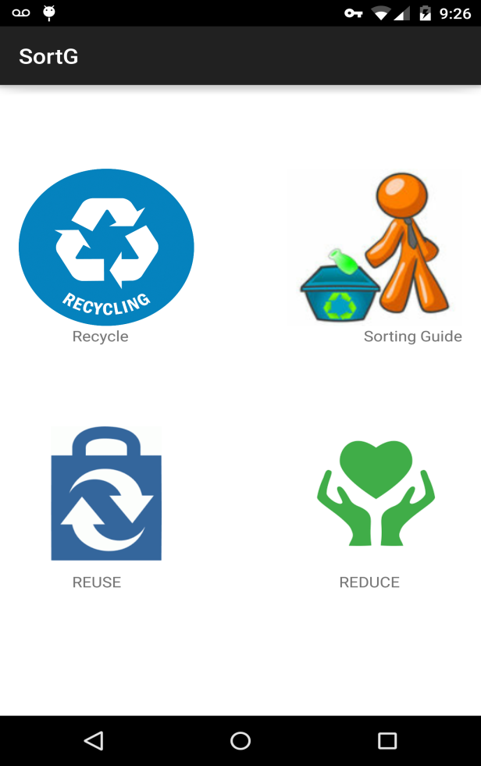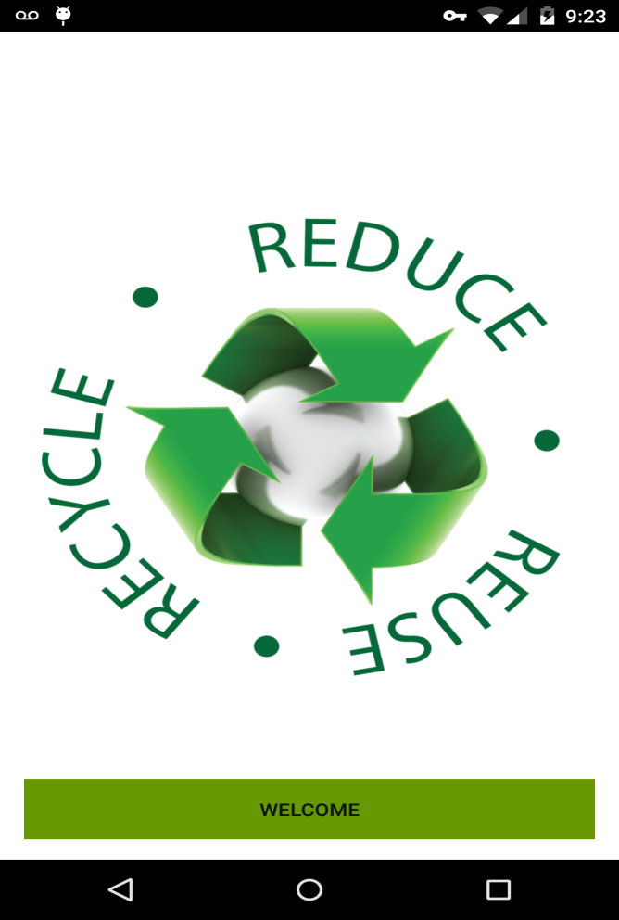 screenshot 1 screenshot 2

When you click on the application this is the first page end user will see and when user clicks on welcome button a voice message will come saying " welcome to recycle world" and it will navigate to the page i.e., shown in screenshot 2 with all the four services.

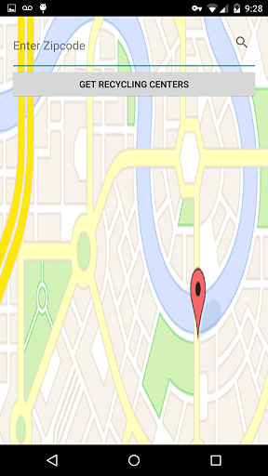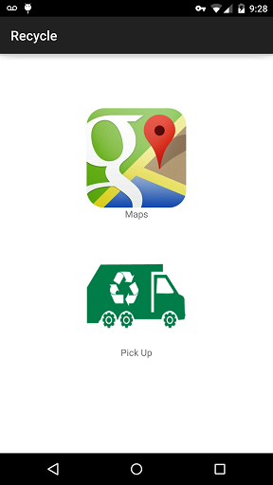

screenshot 3 screenshot 4

Once you click on Recycle button, It will display the screenshot 3 displaying pick up or Maps. If you click on Maps It will ask for the Zip code.

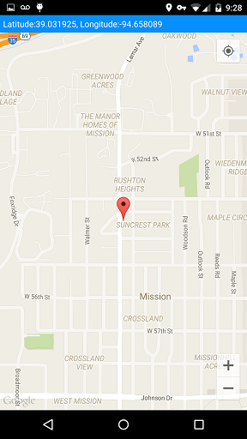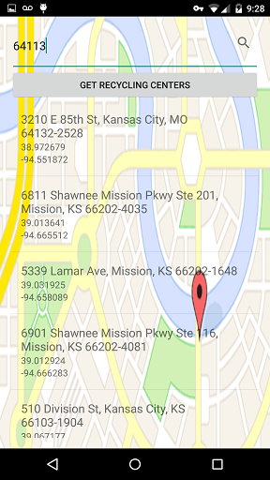

screenshot 5 screenshot 6

After entering Zip code it will display the list of recycle centers that are near to that Zip code and once you click a particular recycle center, It will show the directions to that place.

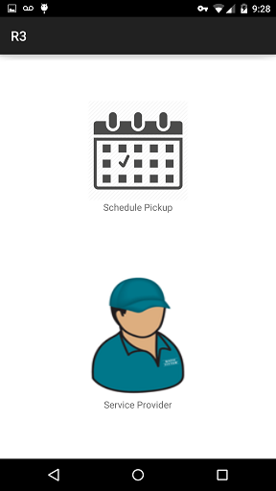

screenshot 7

Once you click on pick up it will display the above screen. If you want to schedule a pick up then you have to click on schedule pick up.

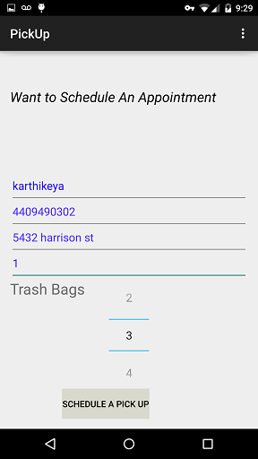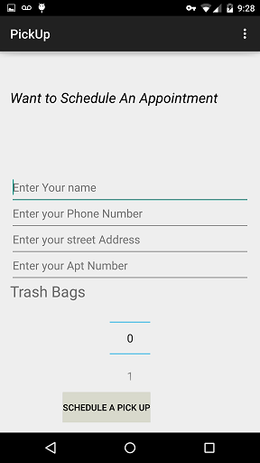

screenshot 8 screenshot 9

It will ask for details once you enter the details click on schedule pickup. It will navigate to screenshot 10.

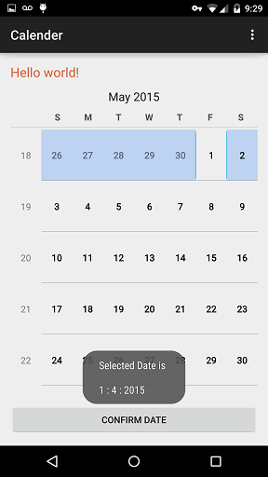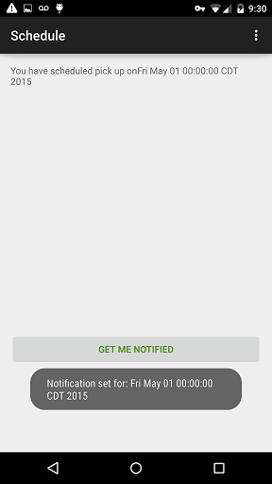

screen shot 10 screen shot 11

Here you have to select the date which you intend to select and click on Confirm date then you will be navigated to the page displaying screen shot 11. and by using get me notified we can send the message and notification to the mobile on that particular date.

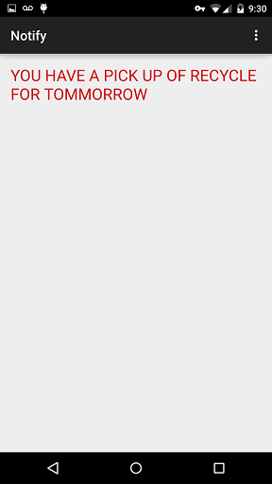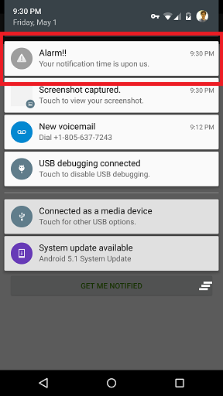

screenshot 12 screenshot 13

The above screen shots shows how the notification will be send to the mobile.

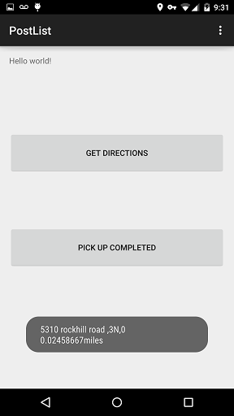

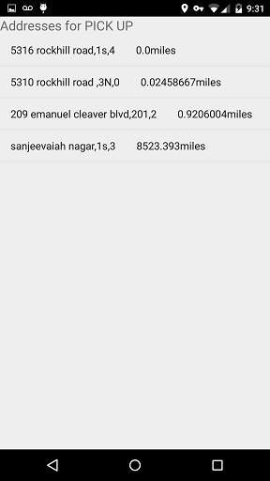

screenshot 14 screenshot 15 screenshot 16

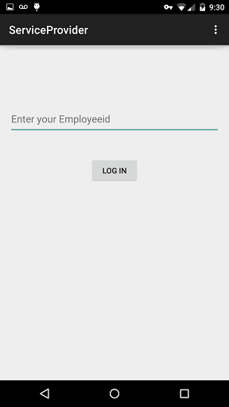

If you click on service provider in screen shot 7. Then it will ask for the employee id. After entering employee ID it will display the list of pickups on that particular day. Once he click on a particular address it will ask for whether to get directions or else to notify the user pickup is completed.

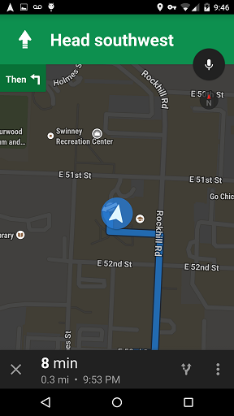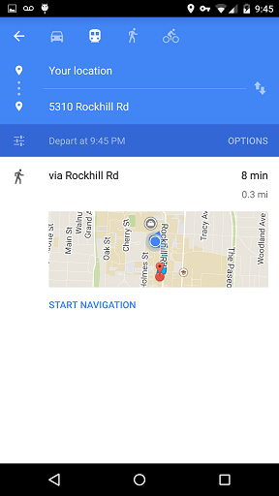

screen shot 17 screen shot 18

Once he click on get directions he will be directed to the pickup location from his current location and also provided with navigation support. If he want navigation it will navigate him to his chosen destination.

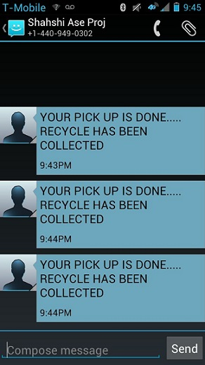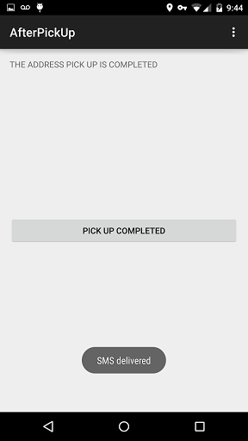

screenshot 19 screenshot 20

If pickup has been completed then the service provider will send a message to user that pickup is completed. After this a message will be delivered to his mobile number which can be seen above.

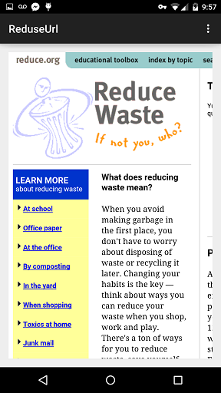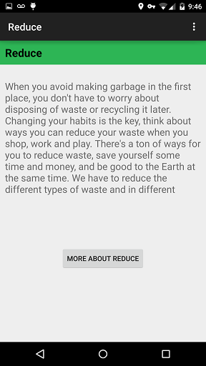

screen shot 21 screen shot 22

This reduce service is to provide extra information for the user to get user friendly environment. If he click on more about reduce he will redirected to the screenshot 22.

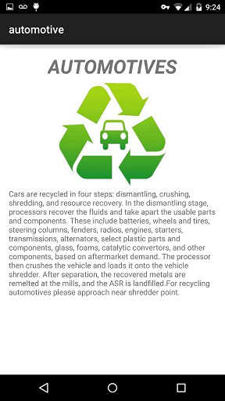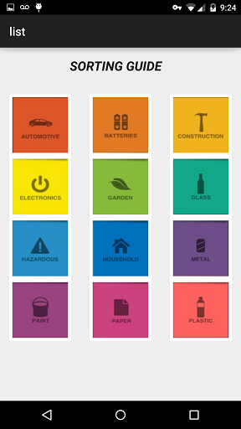

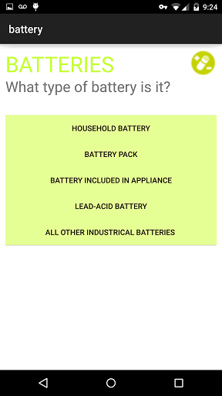

This picture shows us regarding list activity which consist of several image buttons each having specific functionality. User can click on image button to retrieve information according to the problem. Each and every functionality will work as provided in screen shots. All activities are shown below.

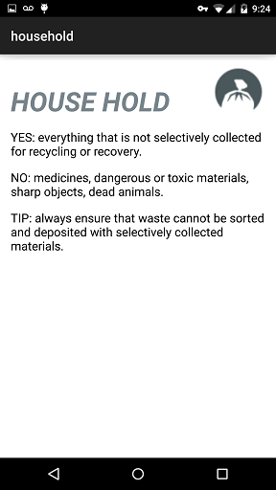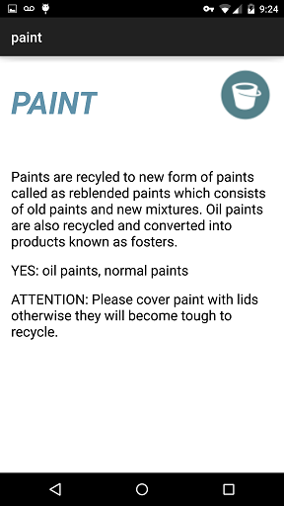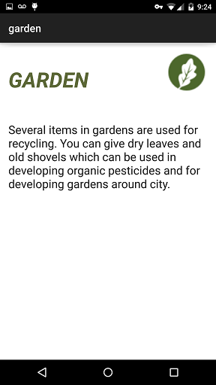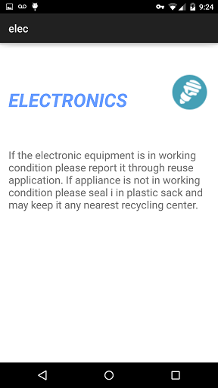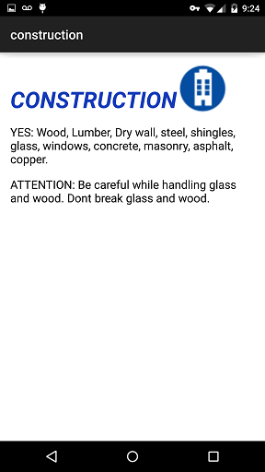 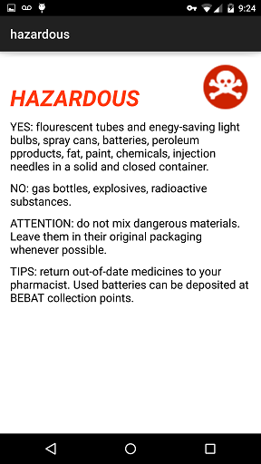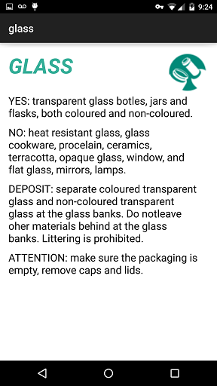

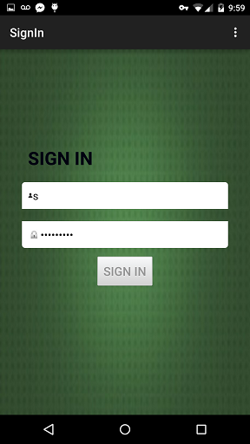

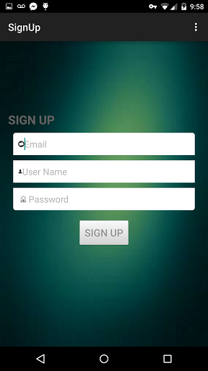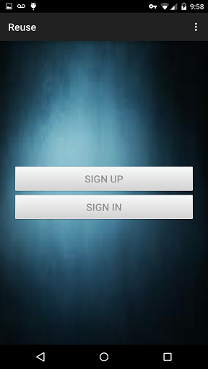

The above three screen shots are for reuse service if he wants to upload item or buy item he has to first sign in by providing credentials .

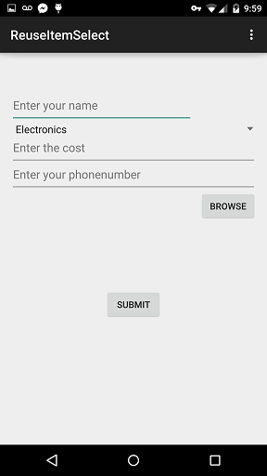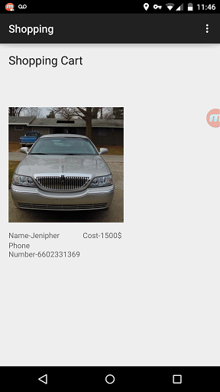

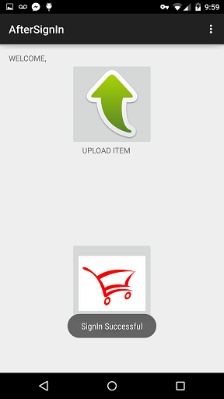

After sign in it will ask whether you want to upload an item or shop an item. If you click on upload an item it will ask to enter the details and select the picture of item and on submit it will store in SQL server. If we click on shop item it will display a list view consisting of several items where user can see the details along with image and contact user on his own by info provided for the product required.

**Troubleshooting:**

* If you have any issues while installing, please remove the APK and reload it.